**BÀI TẬP THỰC HÀNH SỐ 1**

**Lập trình Python căn bản**

**1.Formatted Twinkle Poem**

Write a Python program to print the following string in a specific format (see the output).  
*Sample String :* "Twinkle, twinkle, little star, How I wonder what you are! Up above the world so high, Like a diamond in the sky. Twinkle, twinkle, little star, How I wonder what you are"  
*Output :*

Twinkle, twinkle, little star,

How I wonder what you are!

Up above the world so high,

Like a diamond in the sky.

Twinkle, twinkle, little star,

How I wonder what you are

**Program:**

a="Twinkle, twinkle, little star,"

b="How I wonder what you are!"

c="Up above the world so high,"

d="Like a diamond in the sky."

print(f"{a}\n\t{b}\n\t\t\t{c}\n\t\t\t{d}\n{a}\n\t{b}")

**Result:**

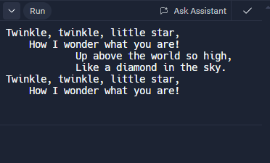

**2. Python Version Checker**

Write a Python program to find out what version of Python you are using.

**Program:**

import sys

print("Phiên bản python:"+sys.version)

**Result:**

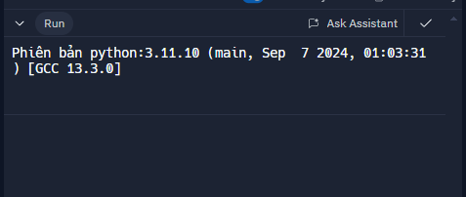

**3. Current DateTime Display**

Write a Python program to display the current date and time.

Sample Output :

Current date and time :

2014-07-05 14:34:14

**Program**

import datetime

x=datetime.datetime.now()

print(f"thời gian bây giờ là:{x}")

**Result**



**4. Circle Area Calculator**

Write a Python program that calculates the area of a circle based on the radius entered by the user.  
Sample Output :  
r = 1.1  
Area = 3.8013271108436504

**Program:**

import math

def s_hinh_tron(n):

tich=0

Pi=math.pi

tich=n*n*Pi

return tich

n=float(input("r=:"))

print(f"Arena={s_hinh_tron(n)}")

**Result:**

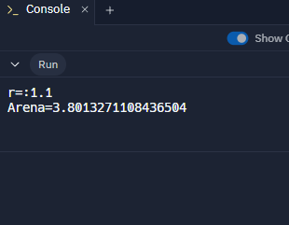

**5. Reverse Full Name**

Write a Python program that accepts the user's first and last name and prints them in reverse order with a space between them.

**Program:**

a=input("Nhập Tên:").strip()

b=input("Nhập Họ:").strip()

print(f"{b} {a}")

**Result:**

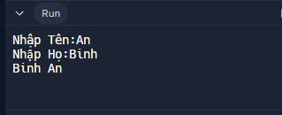

**6. List and Tuple Generator**

Write a Python program that accepts a sequence of comma-separated numbers from the user and generates a list and a tuple of those numbers.  
Sample data : 3, 5, 7, 23  
Output :  
List : ['3', ' 5', ' 7', ' 23']  
Tuple : ('3', ' 5', ' 7', ' 23')

**Program**

n=input("Nhập chuỗi số tách nhau bởi dấu',':")

a=n.split(",")

b=tuple(a)

print(f"List :{a}")

print(f"Tuple :{b}")

**Result**

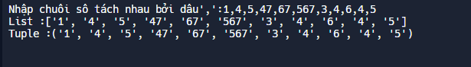

**7. File Extension Extractor**

Write a Python program that accepts a filename from the user and prints the extension of the file.  
Sample filename : abc.java  
Output : java

**Program**

filename=input("Nhập Tên File:")

t=filename.split('.')

print(t[1])

**Result**

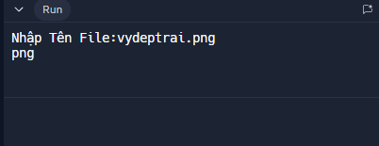

**8. First and Last Colors**

Write a Python program to display the first and last colors from the following list.  
color_list = ["Red","Green","White" ,"Black"]

**Program:**

color_list = ["Red","Green","White" ,"Black"]

afterlist = color_list[0],color_list[-1]

print(afterlist)

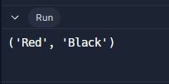

**9. Exam Schedule Formatter**

Write a Python program to display the examination schedule. (extract the date from exam_st_date).  
exam_st_date = (11, 12, 2014)  
Sample Output : The examination will start from : 11 / 12 / 2014

**Program**

date=input("Nhập ngày tháng năm theo đúng trình tự:dd,mm,yyyy: ")

daten=date.split(',')

print(f"{daten[0]}/{daten[1]}/{daten[2]}")

**Result:**

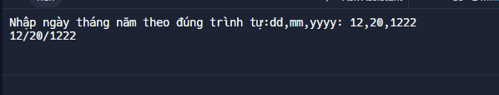

**10. Number Expansion Calculator**

Write a Python program that accepts an integer (n) and computes the value of n+nn+nnn.  
Sample value of n is 5Expected Result : 615

**Program**

def Tong(n):

tong = 0

tong=n+(n*11)+(n*111)

return tong

n=int(input("Nhap n: "))

print(f"Result={Tong(n)}")

**Result**

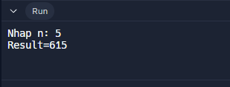

**11. Function Documentation Printer**

Write a Python program to print the documents (syntax, description etc.) of Python built-in function(s).  
Sample function : abs()Expected Result :  
abs(number) -> number  
Return the absolute value of the argument.

**Program**

n=int(input("Enter the number: "))

def abs(n):

if(n>0):

return n

else:

return -n

print(abs(n))

**Result:**

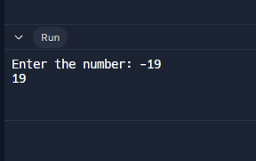

**12. Monthly Calendar Display**

Write a Python program that prints the calendar for a given month and year.  
Note : Use 'calendar' module.

**Program:**

import calendar

nam=int(input("Nhập năm đi em:"))

Thang=int(input("Nhập tháng nữa em:"))

print(calendar.month(nam,Thang))

**Result:**

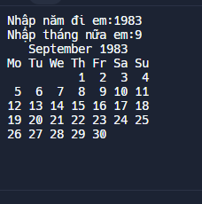

**13. Multi-line Here Document**

Write a Python program to print the following 'here document'.  
Sample string :  
a string that you "don't" have to escape  
This  
is a ....... multi-line  
heredoc string --------> example

**Program:**

text = """a string that you "don't" have to escape

This

is a ....... multi-line

heredoc string --------> example"""

print(text)

**Result:**

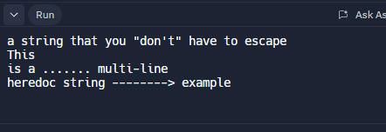

**14. Days Between Dates**

Write a [Python](https://www.w3resource.com/python-exercises/python-basic-exercises.php) program to calculate the number of days between two dates.  
Sample dates : (2014, 7, 2), (2014, 7, 11)  
Expected output : 9 days

**Program:**

import datetime

datetime1=datetime.date(2014,7,2)

datetime2=datetime.date(2014,7,11)

Result=datetime2-datetime1

print(f"{Result.days} Ngày")

**Result:**

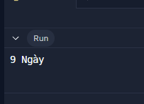

**15. Sphere Volume Calculator**

Write a Python program to get the volume of a sphere with radius six.

**Program**

import math

r=6

def uad(r):

return (4*math.pi*r**3)/3

print(f"Thể tích của hình cầu với bán kính bằng 6 là {uad(r)}")

**Result:**

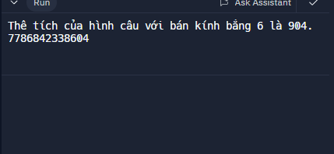

**16. Difference from 17**

Write a Python program to calculate the difference between a given number and 17. If the number is greater than 17, return twice the absolute difference.

**Program**

x=int(input("Nhập 1 số nguyên:"))

def main(x):

if x<=17:

return abs(17-x)

else:

return abs(x-17)*2

print(main(x))

**Result:**

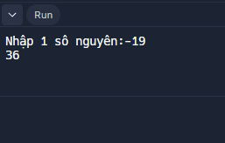

**17. Number Range Tester**

Write a Python program to test whether a number is within 100 of 1000 or 2000.

**Program**

n=int(input("Nhập 1 số nguyên:"))

def tim_so(n):

if 900<=n<=1100:

return True

elif 1900<=n<=2100:

return True

else:

return False

print(tim_so(n))

**Result:**

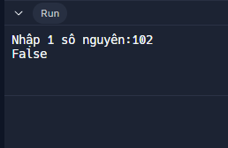

**18. Triple Sum Calculator**

Write a Python program to calculate the sum of three given numbers. If the values are equal, return three times their sum.

**Program:**

a=int(input("Nhập Số A:"))

b=int(input("Nhập Số B:"))

c=int(input("Nhập Số C:"))

def ct3so(a,b,c):

if a==b==c:

return 3*(a+b+c)

else:

return a+b+c

print(f"Tổng 3 số đã nhậplà:{ct3so(a,b,c)}")

**Result:**

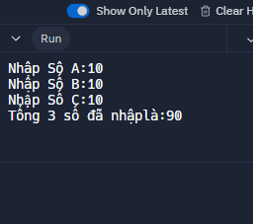

**19. Prefix "Is" String Modifier**

Write a Python program to get a newly-generated string from a given string where "Is" has been added to the front. Return the string unchanged if the given string already begins with "Is".

**Program:**

a=input("Nhập chuỗi: ")

def timChuoi(a):

if a.startswith('Is'):

return a

else:

return "Is"+a

print(timChuoi(a))

Result:

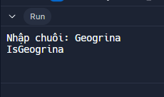

**20. String Copy Generator**

Write a Python program that returns a string that is n (non-negative integer) copies of a given string.

Program

n=int(input("Bạn muốn tạo bản sao mấy lần:"))

chuoi=str(input("Nhập chuỗi:"))

def lap_chuoi(n):

for i in range(n):

print(f"{chuoi}")

lap_chuoi(n)

Result

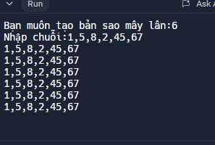

**21. Even or Odd Checker**

Write a Python program that determines whether a given number (accepted from the user) is even or odd, and prints an appropriate message to the user.

Program:

n=int(input("nhập 1 số nguyên dương:"))

def chan_le(n):

if n%2==0:

return "số chẵn"

else:

return "số lẽ"

print(chan_le(n))

Result:

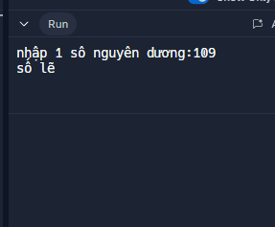

**22. Count 4 in List**

Write a Python program to count the number 4 in a given list.